**Aim- To implement lamda Function.**

**Login to Aws account-**

**Search S3 ,click on the option below shown-**

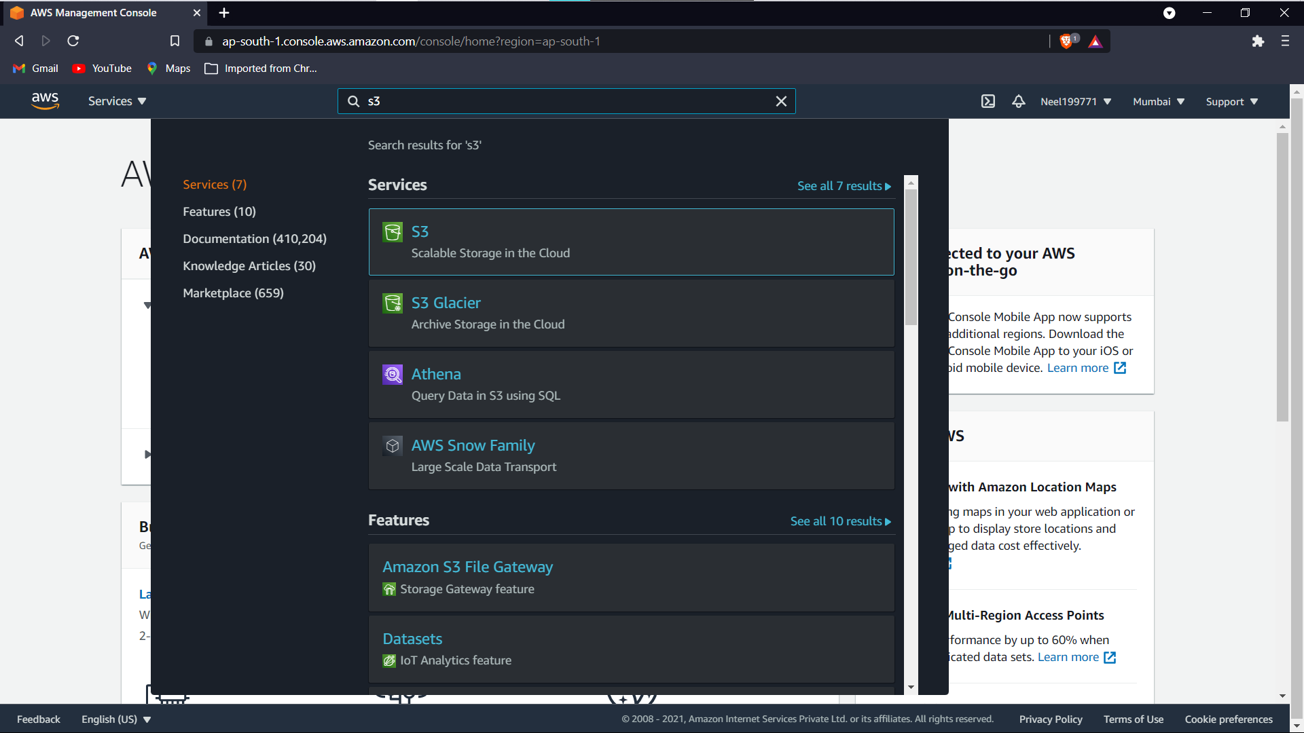

**Create an S3 bucket by giving it a name**

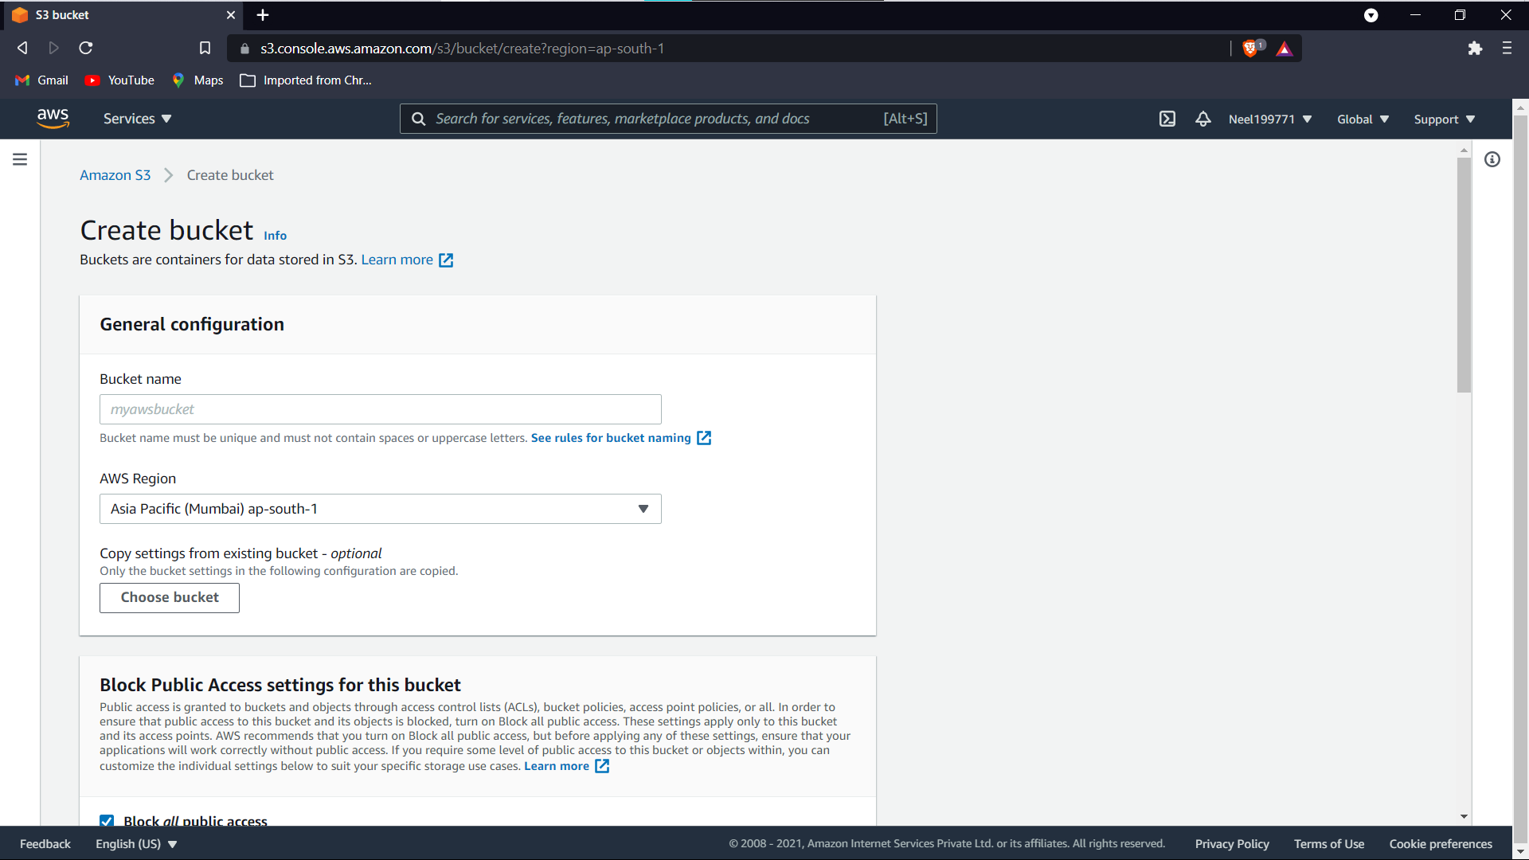

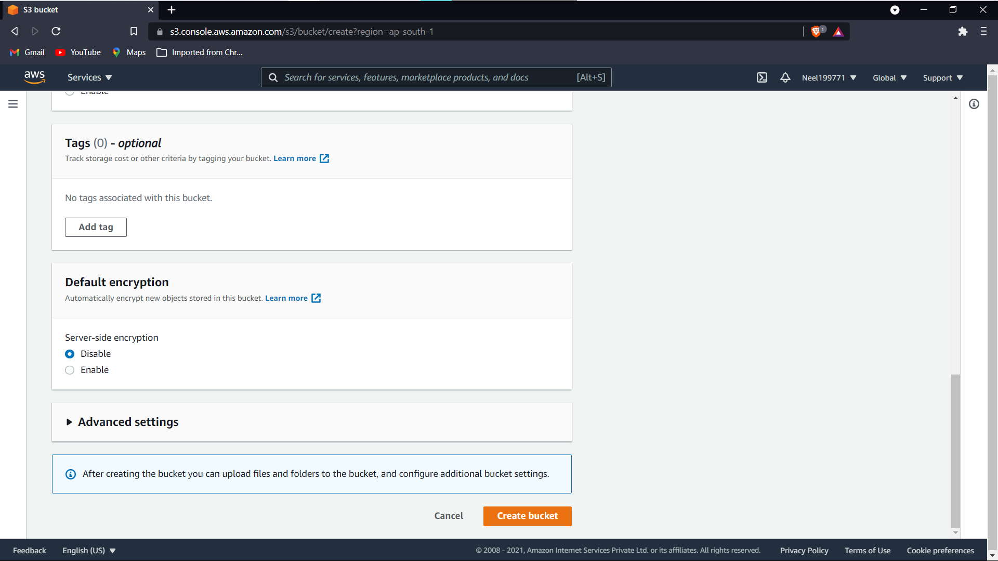

**Click on upload button after the s3 bucket is created in the object section**

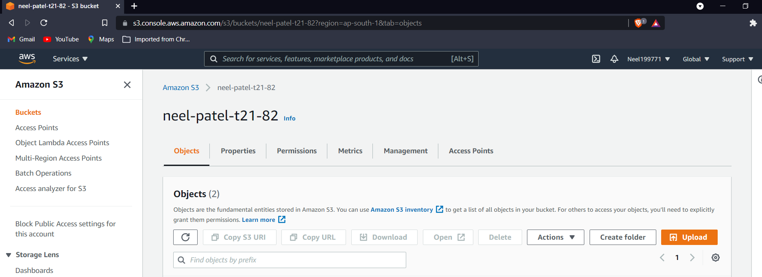

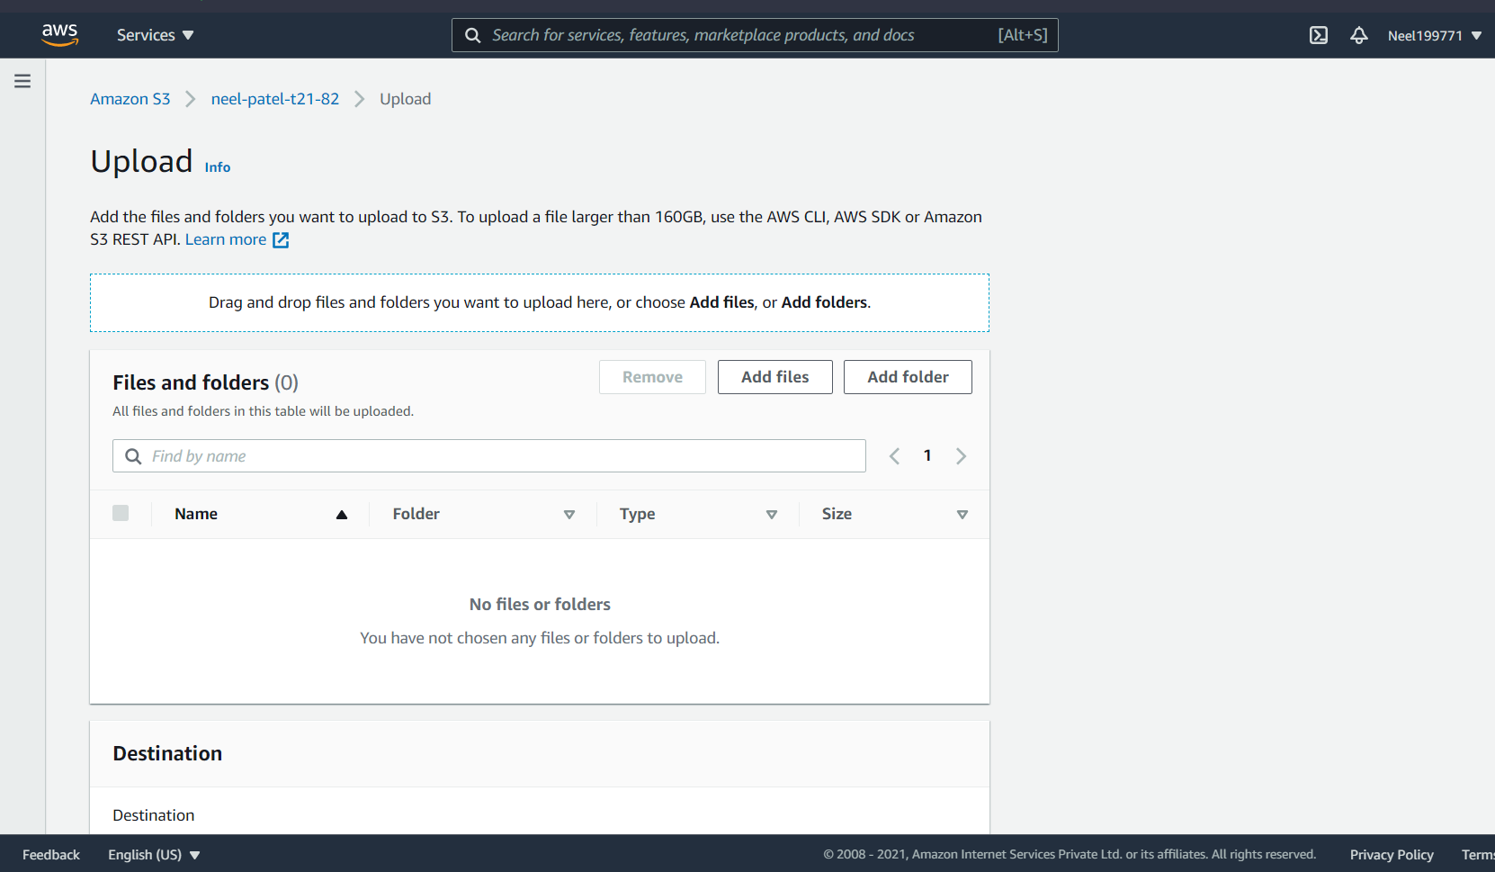

**Add any .py or .java extenstion file and click on upload**

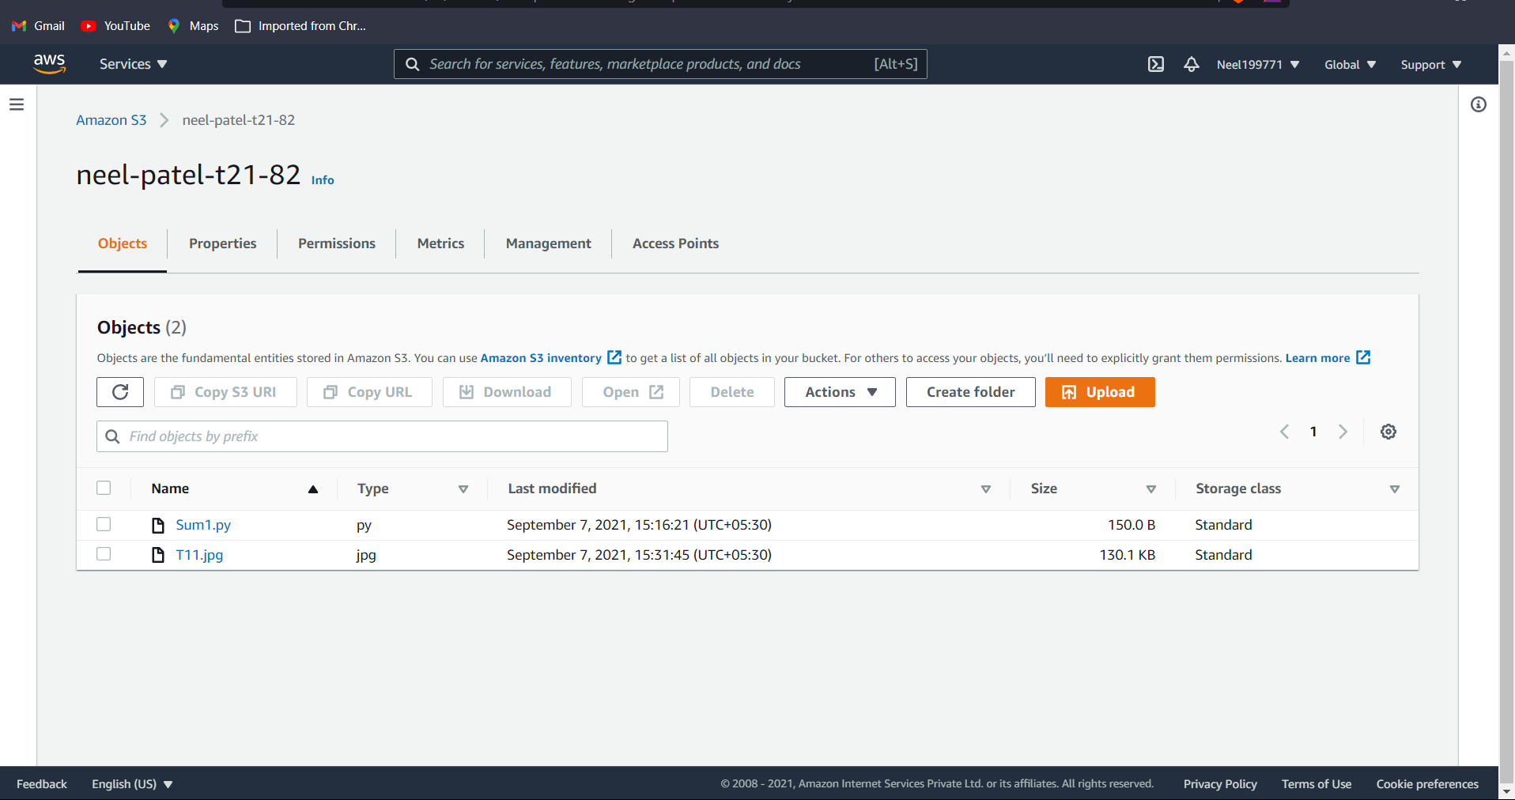

**Now search Lamda**

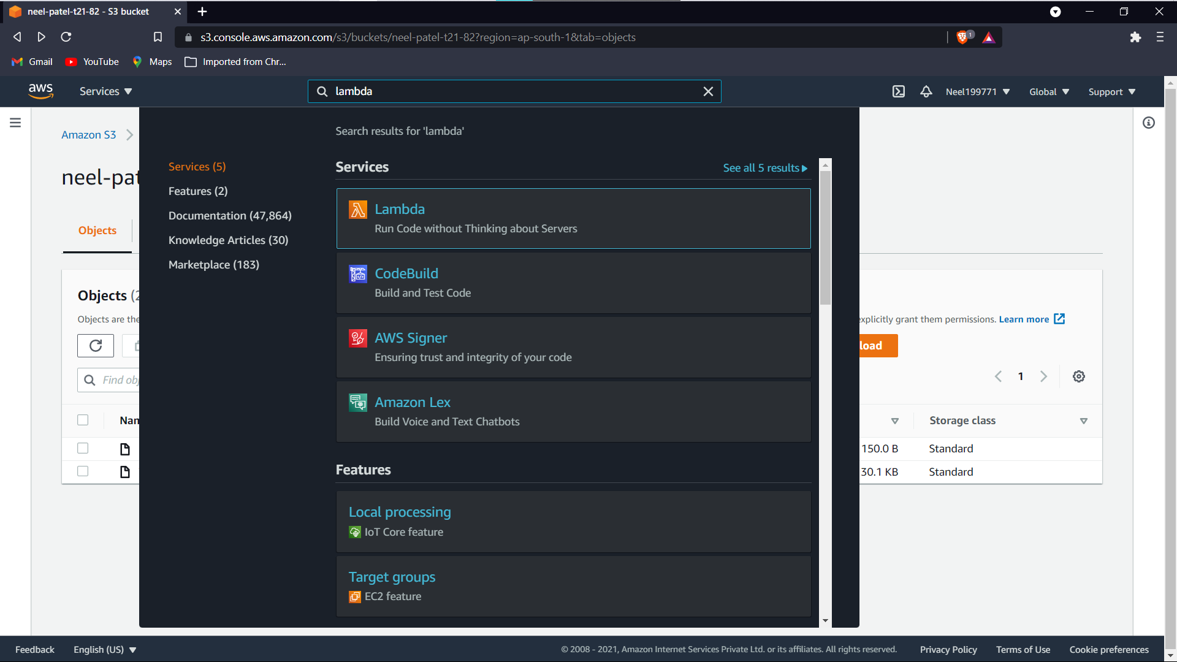

**Click create function**

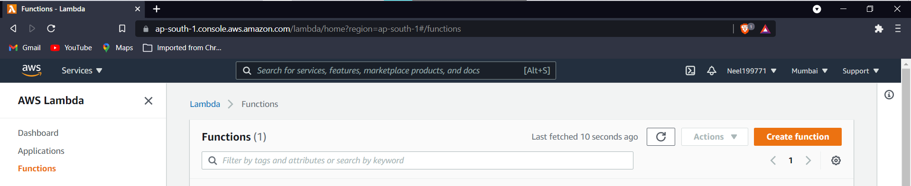

**Click on below options and click on configure**

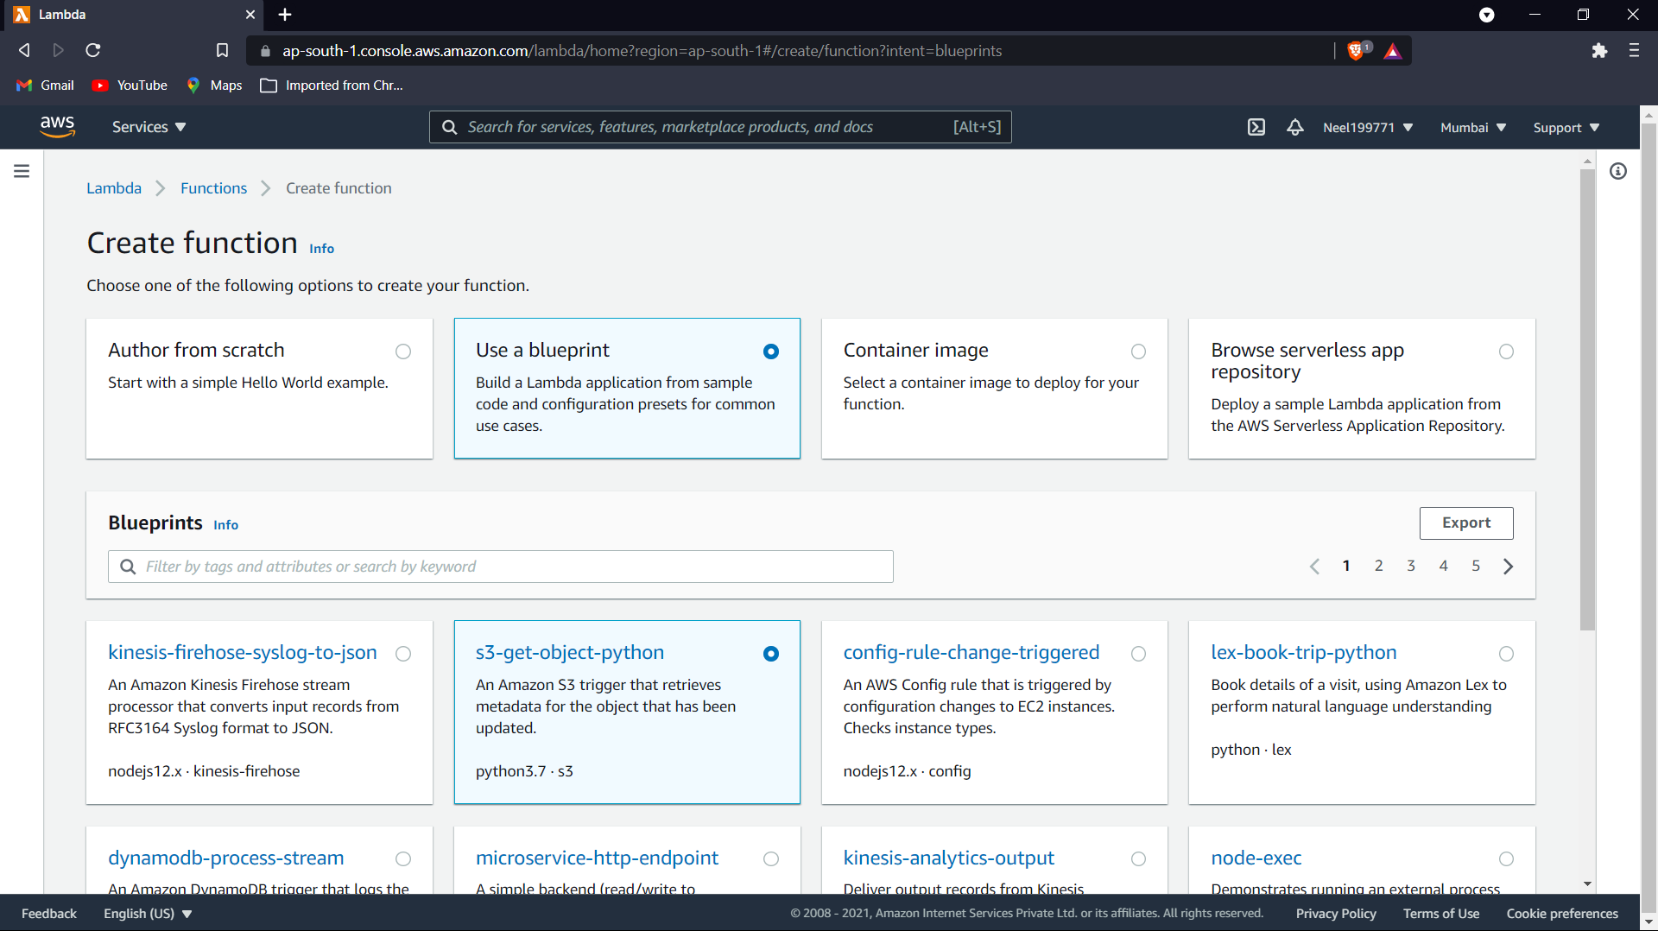

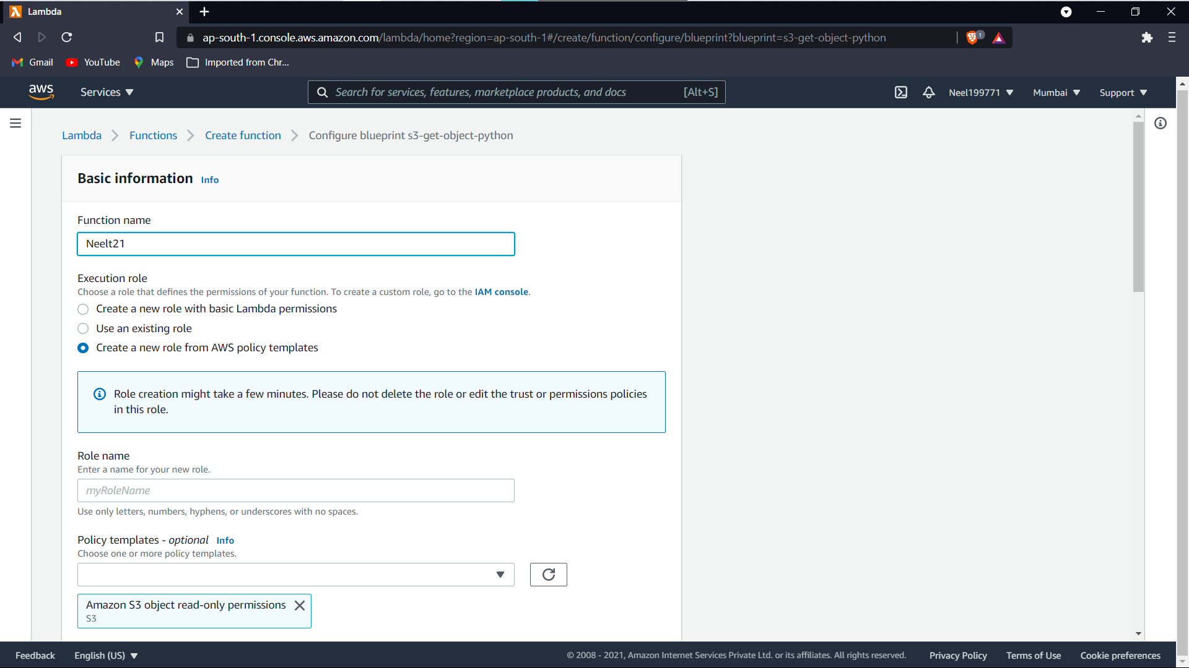

**Select the bucket created and create trigger ,click on create function-**

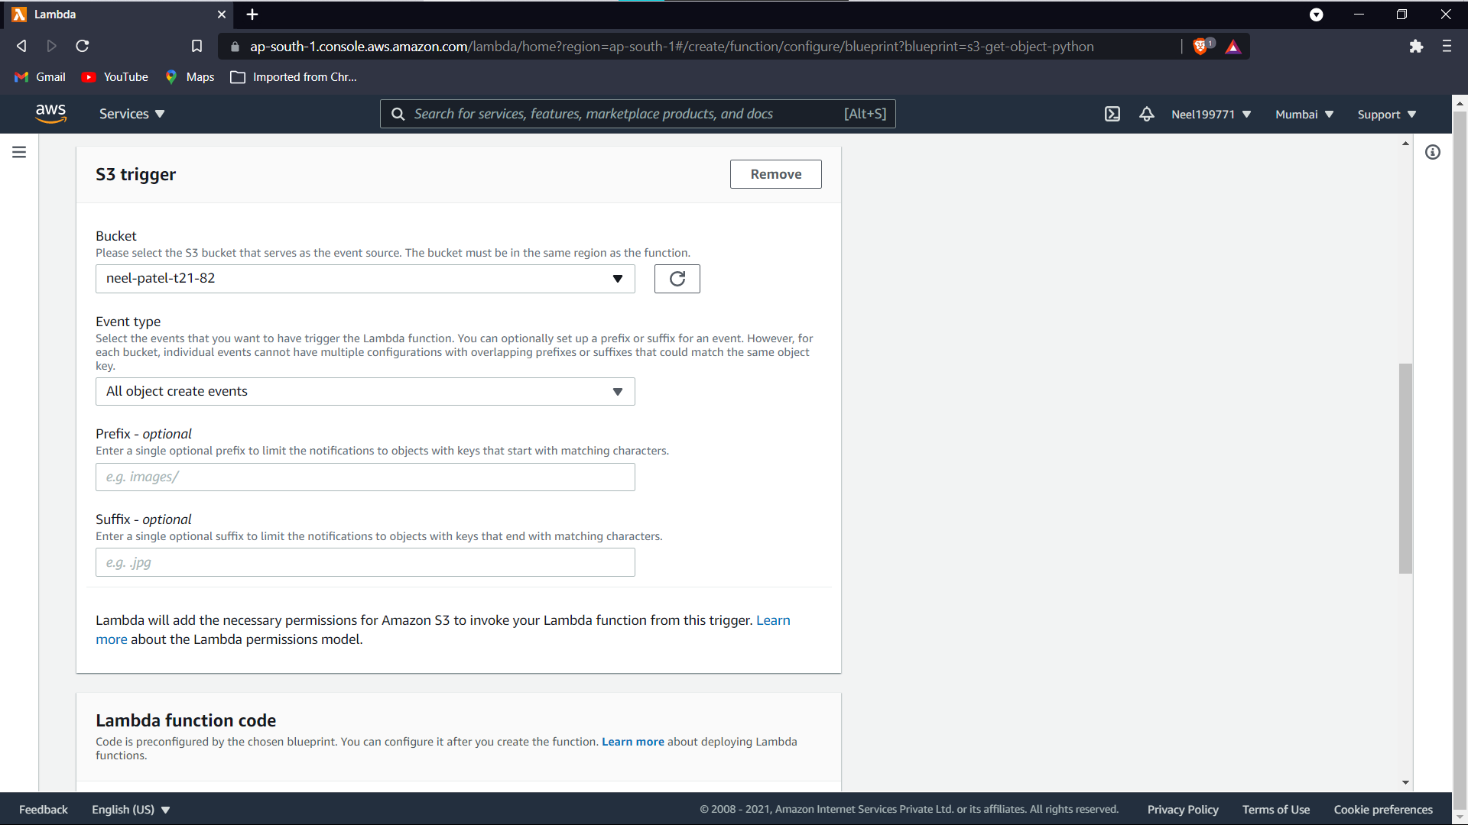

**Check the given trigger is created**

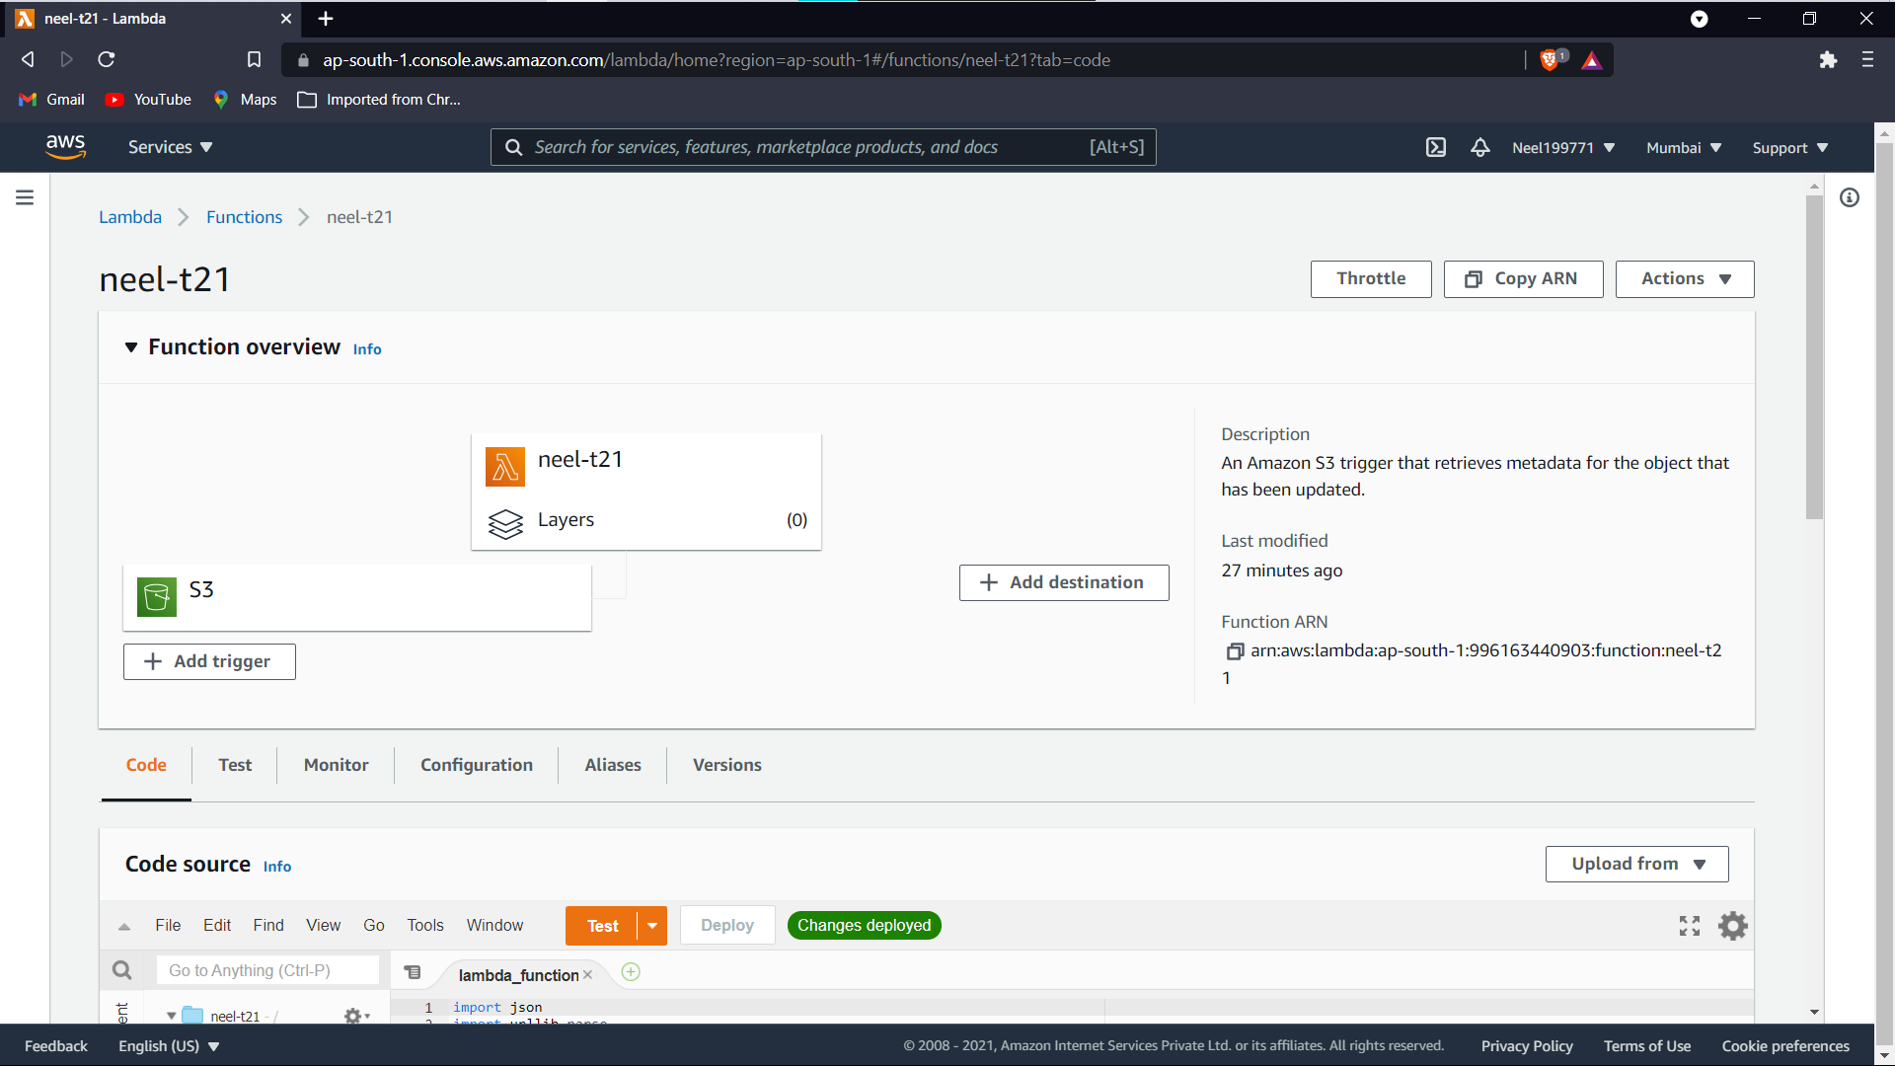

**Click on the orange test button-**

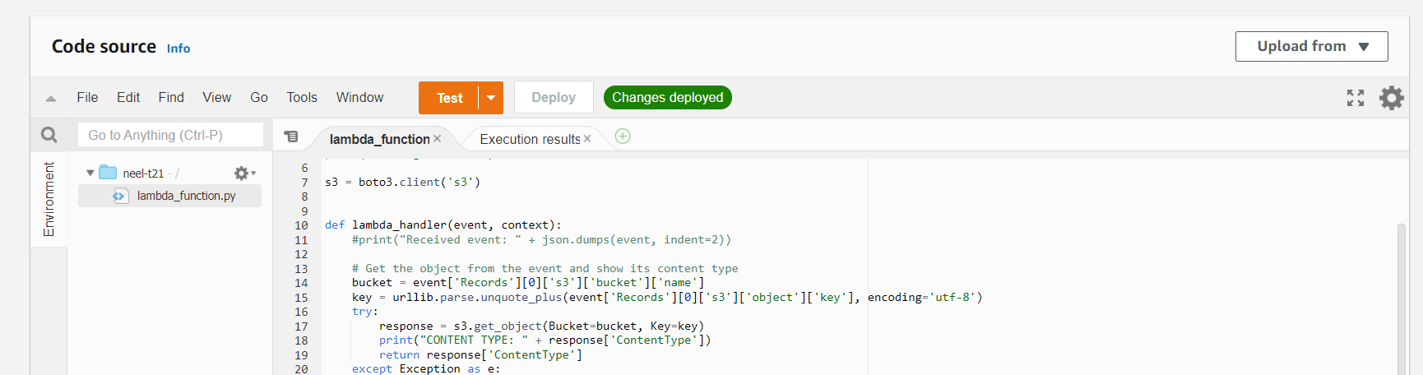

**Now,**

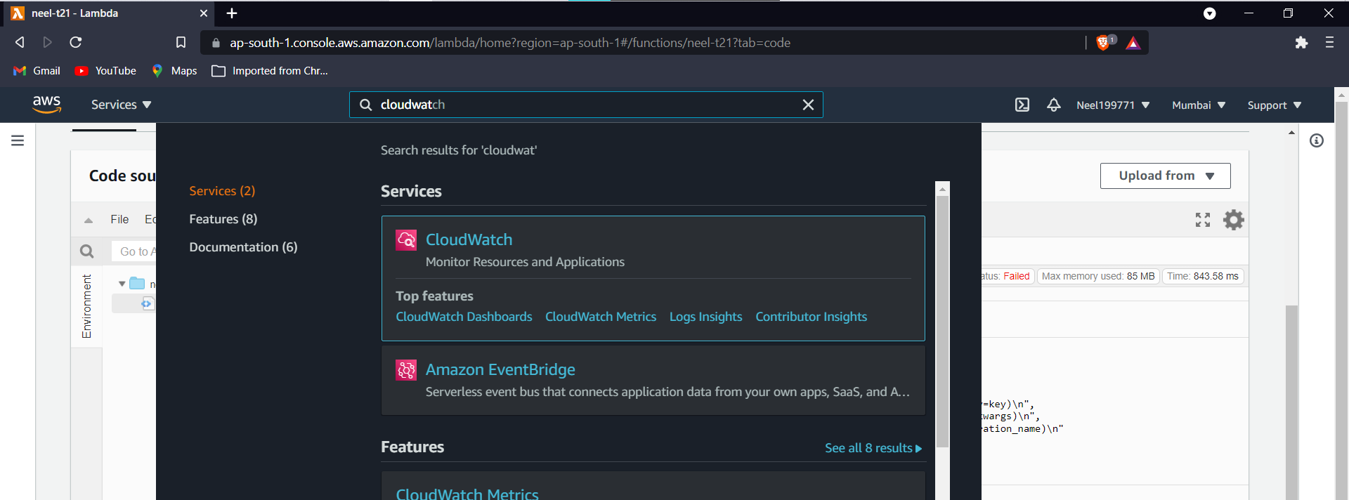

**Check the logs of the test-**

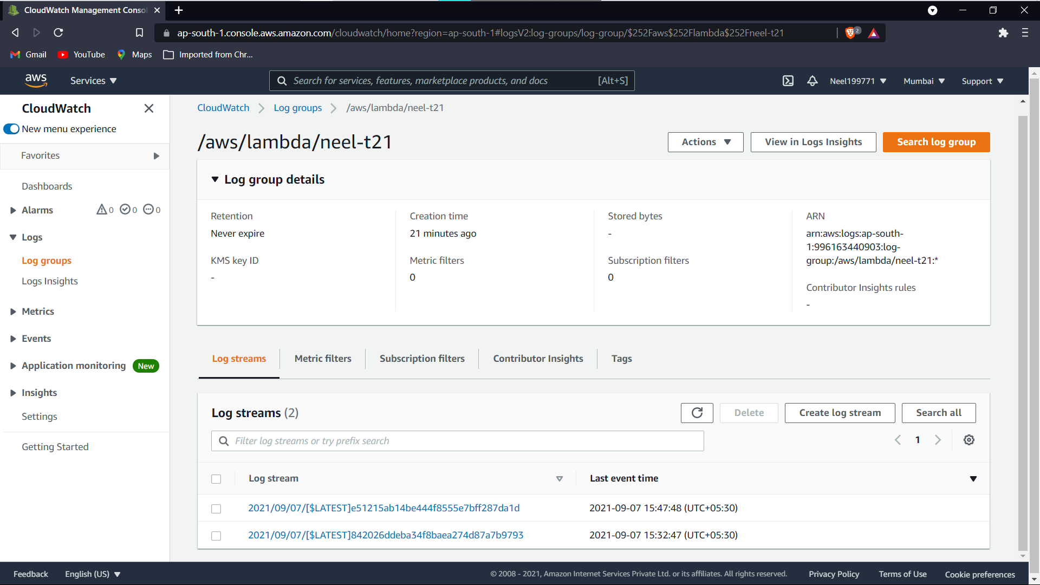

**Now terminate-**

**Click on delete function.**

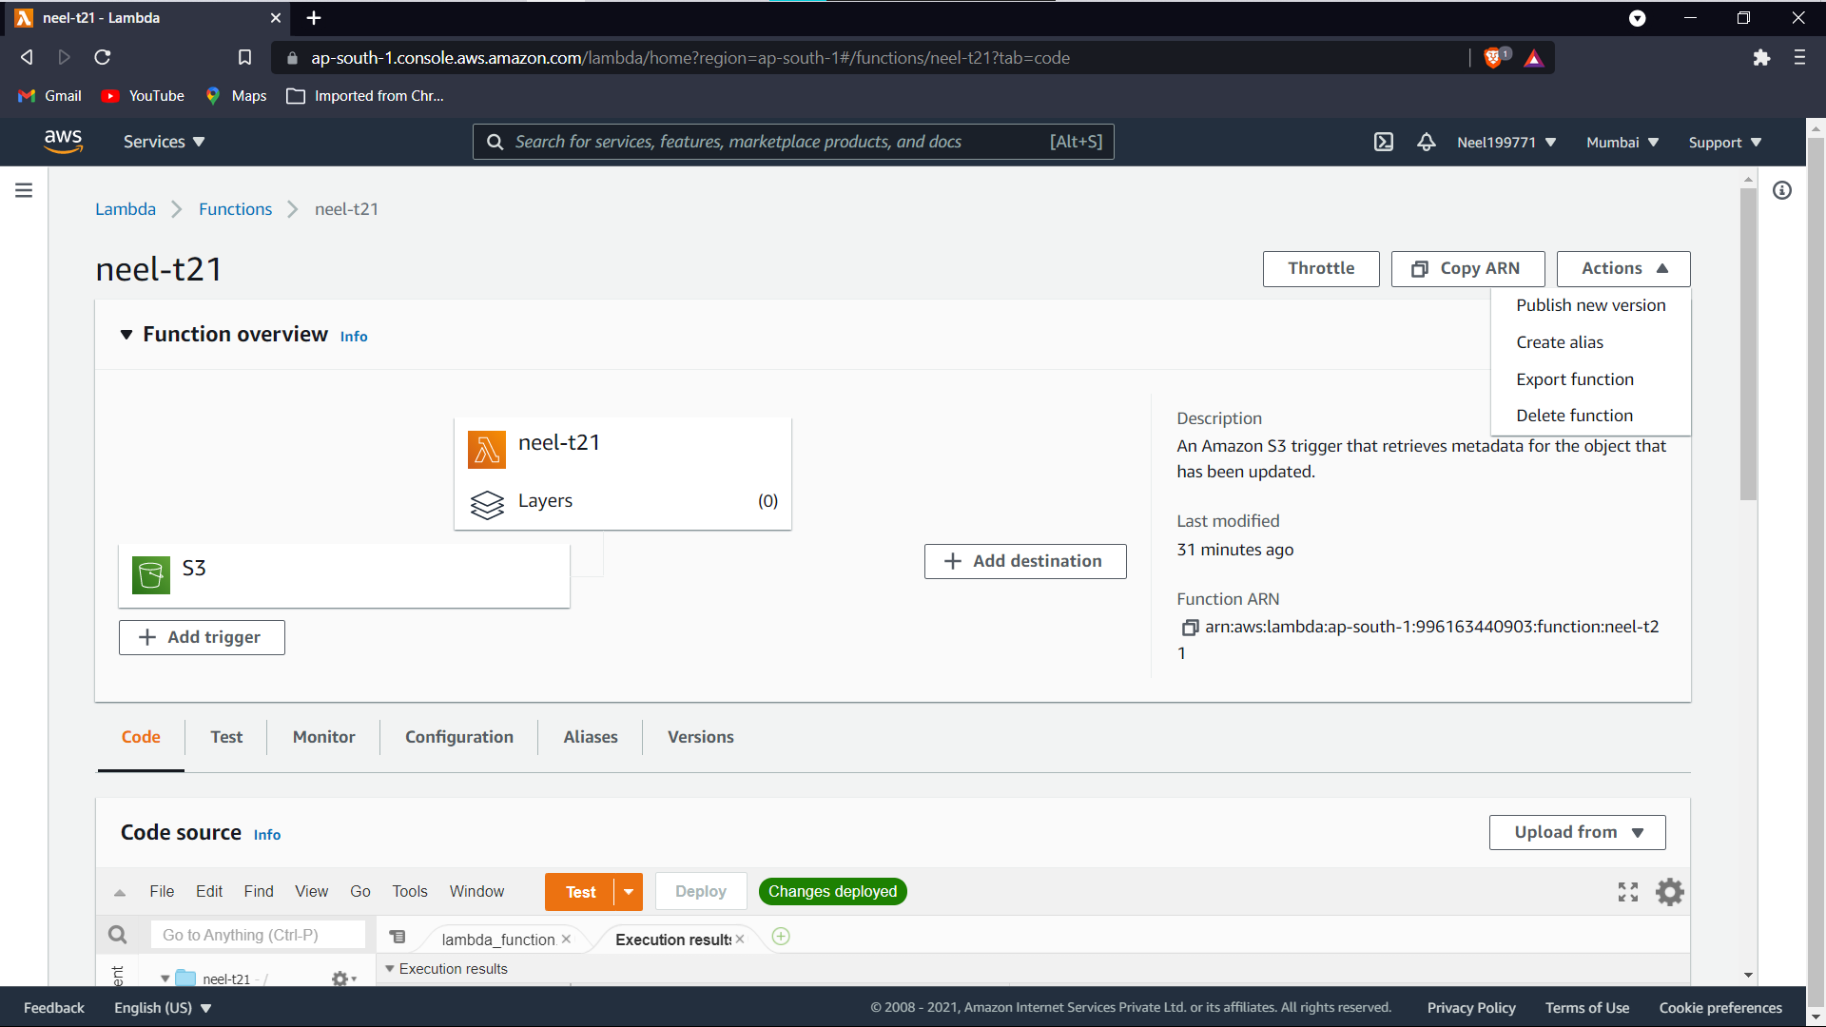

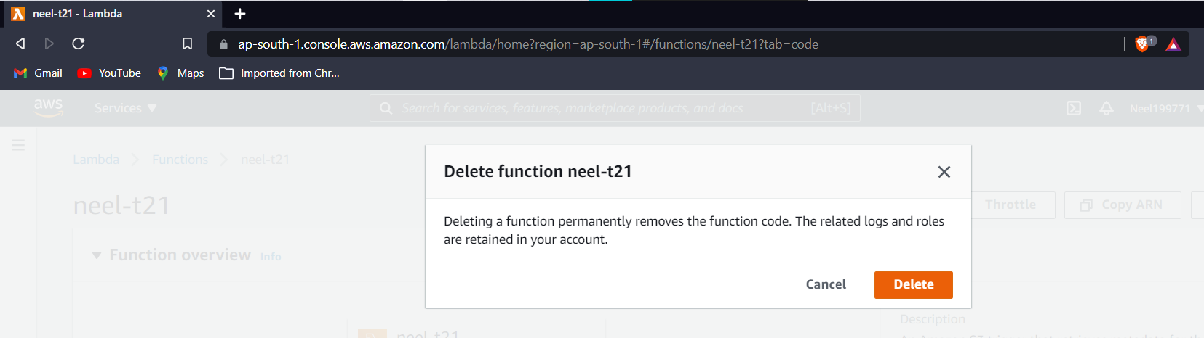

**Empty bucket**

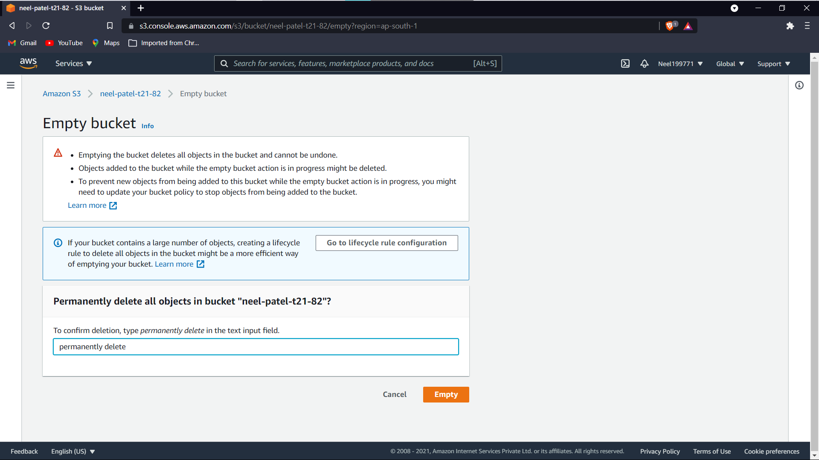

**Delete bucket-**

